Teaching future ready graduates: Embedding ‘future ready’ employability capabilities in university courses
A practical workshop for teachers.

Facilitator Guide

Instructions on how to use this guide
This document includes guidance and information for those who wish to facilitate the Embedding Employability in the Curriculum workshop.
Workshop materials and an inventory checklist can be found in the workshop package.
The workshop is interactive. Messages are communicated through presentation and reinforced by discussion and exercises.
Timing is indicative and may be varied to suit your audience. You may wish to shorten or lengthen activities depending on the expertise and experience of your audience.

Contents

Instructions on how to use this guide 2
Contents 3
Before the workshop 5
Invitation to participation 5
Registration and attendance 5
Name tag 5
Room layout 5
Tea and coffee 5
Adapting the PowerPoint slides 5
Preparing a written bio 5
Inventory checklist 5
Workshop overview 6
Part A: Introduction (15 min) 7
Objectives 7
Activities and timing 7
Resources 7
Part B: Define employability with an icebreaker activity (20 min) 8
Objectives 8
Icebreaker Option 1 – (15 mins) 8
Icebreaker Option 2 – (15 mins) 8
Resources 9
Part C: Transformational teaching and the 4Es framework (25 min) 10
Objectives 10
Activities and timing 10
Resources 11
Part D: Findings from the research project (10 min) 12
Objectives 12
Activities and timing 12
Resources 12
Break (15 min) 13
Resources 13
Part E: A shared design challenge (25 min) 14
Objectives 14
Activities and timing 14
Resources 14
Part F: Embed employability into your course (25 min) 15
Objectives 15
Activities and timing 15
Resources 16
Part G: The dream (10 min) (3–hour workshops only) 17
Objectives 17
Activities and timing 17
Resources 17
Part H: Eight crazy minutes (15 min) (3–hour workshops only) 18
Objectives 18
Activities and timing 18
Resources 18
Part I: Reflection and evaluation (20 min) 19
Objectives 19
Activities and timing 19
Resources 19
Attachment: Inventory checklist 20

Before the workshop

Invitation to participation
You should send an Invitation to Participate Letter to potential participants. The letter should:
- explain the background of the workshop
- ask participants to think of a course they would like to embed employability in.
A sample letter is in the workshop material package.

Registration and attendance
An attendance template is in the workshop material package.
If meals are provided, remember to gather dietary requirements in advance.

Name tag
Each participant should have a name tag.

Room layout
The room needs projectors for presentation.
The room should be set up as Cabaret or Cluster style (see below) to allow for group discussion. Each group/table should allow for approximately four participants. The number of tables required is dependent on the number of participants.
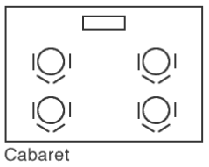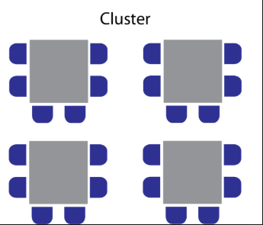

Tea and coffee
If provided, tea and coffee should be ready before the workshop commences otherwise you will end up starting very late.

Adapting the PowerPoint slides
The PPT slides can be customised to reflect your institution and contact details.

Preparing a written bio
You can prepare a written bio for distribution if required.

Inventory checklist
There is an inventory checklist attached to this guide. The checklist will help the facilitator prepare for the workshop.

Workshop overview
Ideally, this is a 3-hour workshop where participants will learn about a powerful pedagogical framework that developed during an Ako Aotearoa funded national research project. Participants will apply the framework to redesign their own courses. A brief overview of the workshop is provided below.
If you are unable to secure a 3-hour slot, it is possible to deliver most of this workshop in 2 hours. The Break, Parts B and some activities can be shortened. Parts G and H will need to be dropped. Both timeframes have been trialled and we have found the 3-hour workshop to be more effective in engaging participants.
Do not drop the icebreaker, however tempted you might be.

Teaching future ready graduates (180 minutes)
Part A | Introduction (15 min.)  The facilitator provides a self-introduction, describes the workshop background and the activities and invites participants to introduce themselves.
Part B | Define the future ready capabilities graduates need (20 min.)  Participants articulate the employability capabilities that ‘future ready’ graduates need and connect them to institutional employability policy documents if any.
Part C | Transformational teaching & the 4Es framework (25 min.)  The facilitator describes the transformational teaching and presents the 4Es framework. Participants use the framework to review their courses.
Part D | Findings from the research project (10 min.)  The facilitator shares the positive deviance approach and the research findings.
Break | Tea (15 min.)
Part E | A shared design challenge (25 min.)  Participants work collaboratively to redesign a course using the 4Es framework.
Part F | Embed future ready capabilities into your course (25 min.)  Participants redesign their courses identified in Part C.
Part G (3 hr workshops only) | The dream (10 mins.)  Participants look beyond their own courses to highlight the forces that act against the dream coming true.
Part H (3 hr workshops only) | Eight crazy minutes (15 min.)  Participants remedy as many challenges noted in Part G as possible.
Part I | Reflection & evaluation (20 min.)  Participants ask questions and provide their evaluation of the workshop.

Part A: Introduction (15 min)

Objectives
This part briefly describes the workshop background and planned activities and provides an opportunity for you (as the facilitator) and the participants to introduce themselves. It also invites participants to join any post-workshop interviews.
Use the following slides.
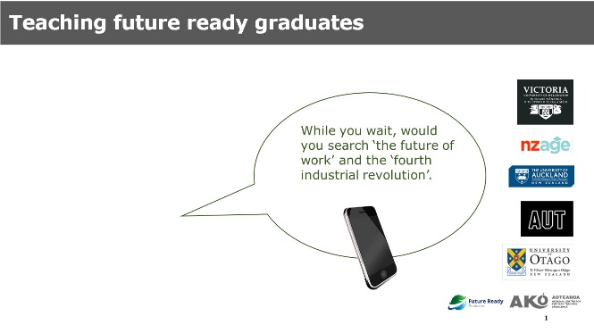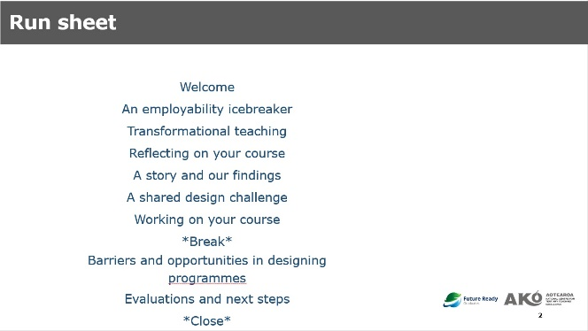

Activities and timing
Before the commencement, invite participants to search ‘the future of work’.
Allow a little time for latecomers and for settling into even sized groups.
Explain that the workshop presents findings from a national research project and aims to equip participants with ideas and techniques to embed employability into theor own teaching.
Invite participants to introduce themselves to each other. If you have a small group, do this as a whole class activity. If you have a big group just make sure the people on each table know each other.
Describe the planned activities.

Resources
- Presentation slides for facilitator
- Name tags
- Pens per participant
- Facilitator bio per table/group

Part B: Define future ready employability capabilities with an icebreaker activity (20 min)

Objectives
This part helps participants recognise future ready employability-related capabilities and introduces/reminds them of relevant institutional documents such as graduate profiles/attributes.

Icebreaker Option 1 – (15 mins)
Use the following slides.
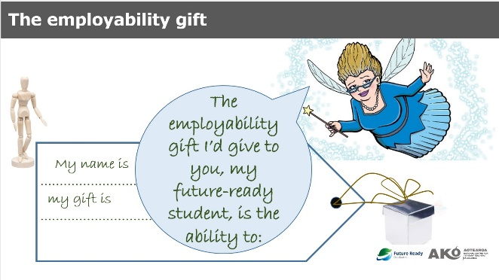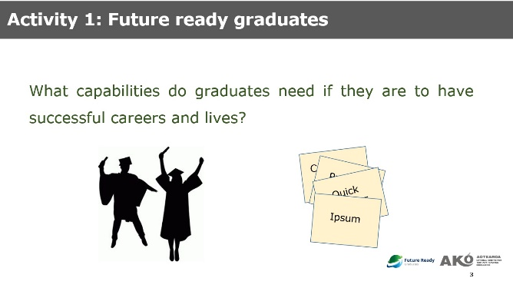
Invite each participant to identify an employability or future ready capability gift to their students (write it down on the tag), share the gift with others in the group. Participants report back to their own group or the whole class (depending on numbers and time).

Icebreaker Option 2 – (15 mins)
Use only the second of the two slides above.
Give participants blank post-it notes and ask them to think of the environment that students will face as they seek to develop their careers and lives – remind participants of rapid change, uncertainty, technological advances, sustainability, etc.
Ask participants to think of as many graduate capabilities as they can in 5 minutes. Participants to write down one attribute per post-it note.
Ask participants to look at each other’s post-it notes.
Make it a fun race encouraging people to generate lots of capabilities (Someone will probably get about 15)
In a 3-hour session you might ask them to sort the post-it notes into themes and feedback.
We recommend using Option 2 if you have some participants who have limited knowledge of employability within a university context or an overly narrow or dated concepton of employability. Note that Option 2 can take a bit longer than Option 1.
This exercise alerts participants to the breadth of future ready employability capabilities. Some will recognise the challenge they face as teachers. Everyone should realise that ALL courses/teachers in university can/should contribute to developing these capabilities.

Following the icebreaker
Display or hand out any institutional employability or graduate profile documents and establish the connection between the employability identified by participants and the employability documented by the institution. Note, in a 2-hour workshop there isn’t much time for this.

Resources
- Presentation slides for facilitator
- Whiteboard marker for facilitator
- Gift tags (Option 1) or post-it notes (Option 2) for each participant
- Institutional document (e.g. graduate profile) per participant
- Pen per participant

Part C: Transformational teaching and the 4Es framework (25 min)

Objectives
This part describes the shift in the teaching practice and presents the 4Es framework. Participants use the framework to review their courses.
Use the following slides.
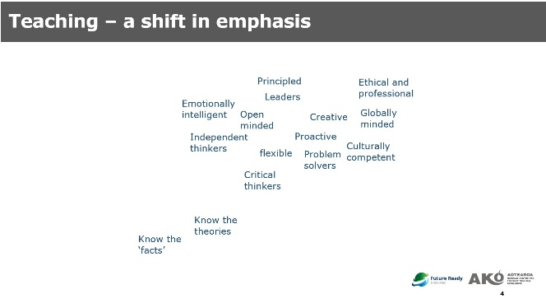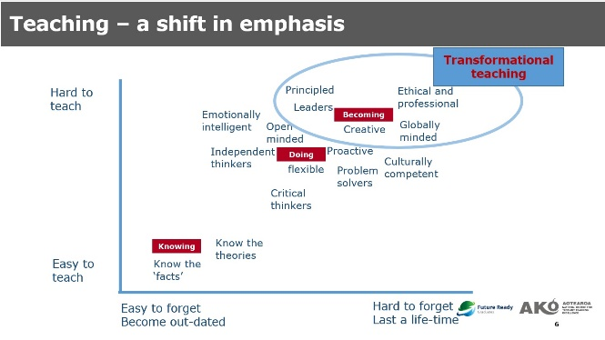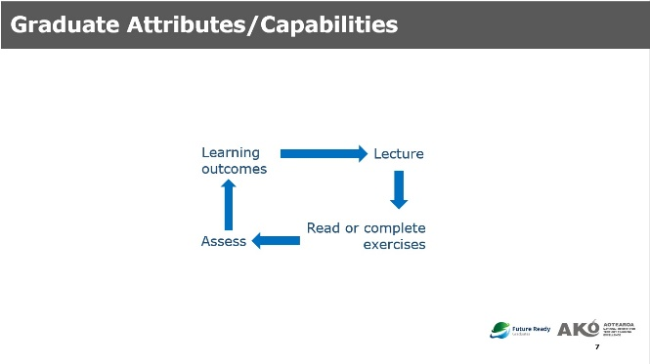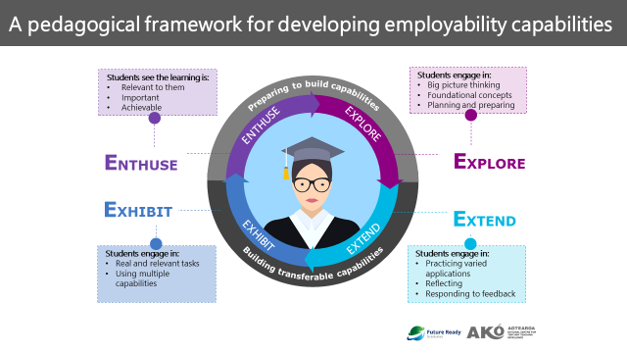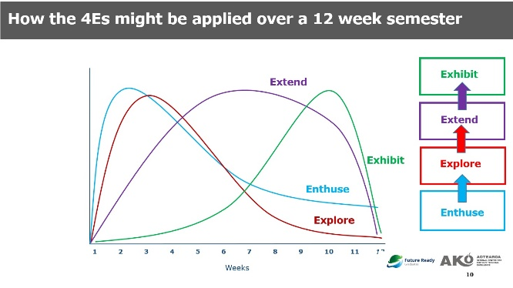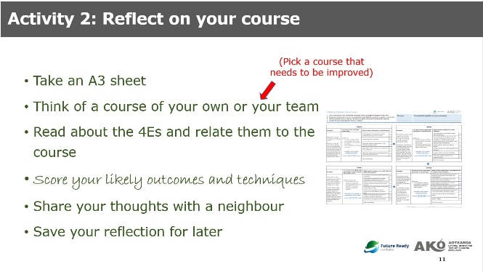
Slide 10
Slide 11
Slide 9
Slide 8
Slide 5
Slide 7

Activities and timing
(7 min) Drawing on the capabilities identified in Part B, explain that in order to develop capabilities in our students, we need to move beyond teaching students to ‘know facts and theories’ – we need to teach students to ‘do more’ and ‘be more’. Point out that we are used to teaching people to know more. The project’s research showed that teaching staff are unsure about how to teach students to become more. To help staff by providing a simple summarising model, the literatures on transformative learning, transformational teaching and the transfer of learning were reviewed and a pedagogical framework developed (slides 5-7). Describe traditional teaching approaches (slide 8) and contrast this with the 4Es framework (slide 9). Stress that the model is robust being informed by a wealth of research.
(18 min) Give participants the reflective tool (Activity 2 sheet). Remind them to work on a course that needs improving – some people find this hard – they want to look expert in everything – you can suggest that they work on a ‘friends’ course if they are stuck.
Ask participants to review their own course against the reflective tool and share their thoughts. Rove around the room to answer questions and explain the framework.

By the end of this exercise participants should be familiar with the framework. Some will be buzzing with ideas for their own courses already. One or two may still think this is nothing to do with their discipline– try to use the feedback time to make it clear that you can and should embed future ready employability capabilities within discipline learning.

Resources
- Presentation slides for facilitator
- Pen per participant
- Activity 2 sheet “reflect on your course” per participant

Part D: Findings from the research project (10 min)

Objectives
This part explains the positive deviance approach that guided the research project and presents the findings from the research project.
Use the following slides.
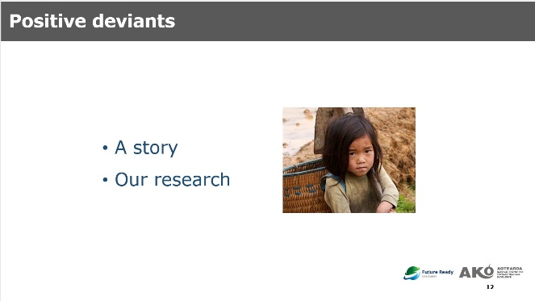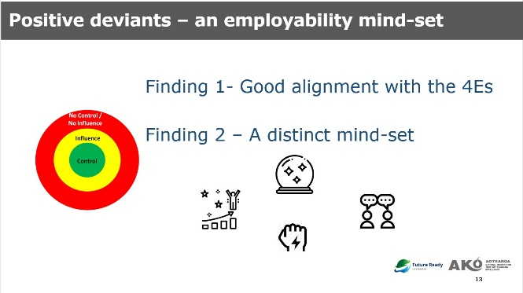

Activities and timing
(10 min) Tell stories about positive deviants and explain the positive deviance approach that guided this research project. Describe the collection and analysis of data and the research findings. (See the website for an explanation)

Resources
- Presentation slides for facilitator

Break (15 min)
Shorten this break to 5 minutes if you are running a 2-hour workshop.

Resources
- Paper cups
- Snacks, sweets & chocolates
- Tea and coffee

Part E: A shared design challenge (25 min)

Objectives
This part prepares participants to apply the 4Es framework by asking them to work collaboratively to resign a course in a given teaching scenario.
Use the following slides.
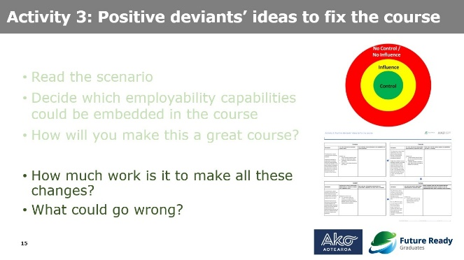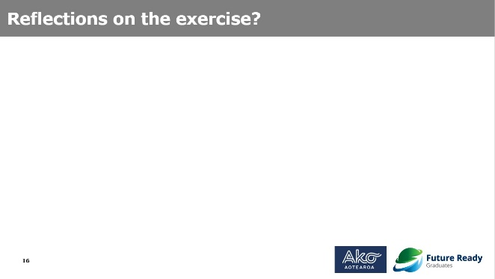

Activities and timing
(3 min) Place a course scenario stand on each table. You can randomly allocate participants to particular scenarios or you can ask participants to move to a table that aligns with their interests and/or discipline. Give each group a course redesign scenario and an Activity 3 sheet (Ideas to fix the course).
Explain that they are going to work in groups to apply the framework to a scenario. This will give them a chance to share ideas and to practice in preparation for applying the framework to their own course later on.
(12 min) Ask participants to discuss the course redesign scenario and identify key problems in their groups. Ask each group to use the 4Es framework to fix the problems and to note their solutions in Activity sheet 3.
(8 min) Ask each group to present their scenario, problems and solutions back to the wider group and acknowledge each group’s contributions.
Capture their thoughts. Make sure you get across that they have been able to come up with good plans. Make sure you let them know that making changes takes time and can be risky – hopefully they have prioritised their plans.

Resources
- Presentation slides for facilitator
- Activity 3 one stand per table/group
- Activity 3 one “course scenario” per table/group
- Activity 3 sheet “ideas to fix the course” per table/group
- Pen per participant
By now they should all be feeling ok about applying the framework to their course.

Part F: Embed employability into your course (25 min)

Objectives
This part allows participants to redesign their own courses using the 4Es framework by applying the ideas and techniques they learned in previous activities.
Use the following slides.
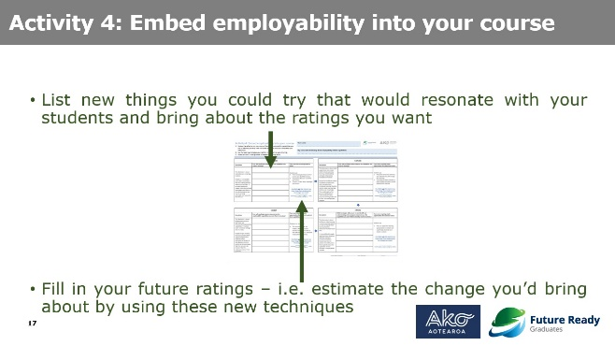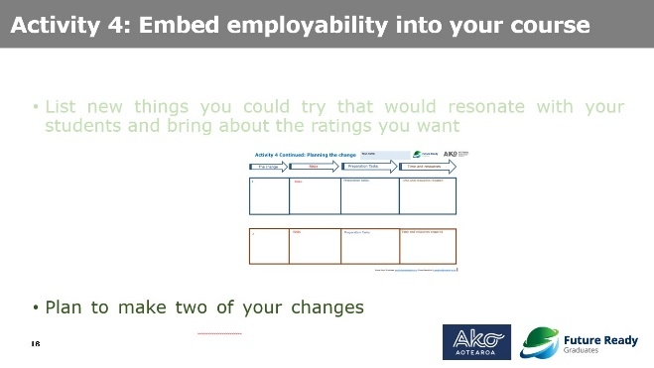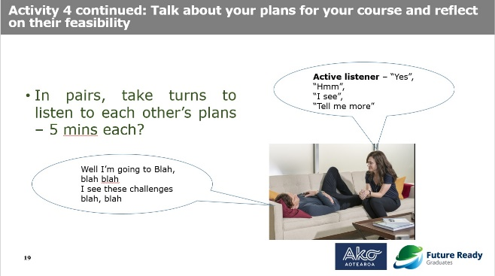

Activities and timing
(4 min) Hand out Activity 4 sheet (embed employability into your course) and Planning sheet to each participant. Participants revisit their course identified in Activity 2 so they need to find the reflection they filled in at the start of the workshop.
Remind participants to be like the positive deviants, especially in considering the characteristics of their students and to design for their people.
Remind them to think of the future reday employability related capabilities they could be building and to write them at the top. (People forget this and if they did it in activity 1 they might want to change their minds now)
(8 min) Ask participants to list techniques that will develop the identified future ready employability capabilities of their students. Ask participants to assess the likely impact of these changes and assess their future 1-5 ratings on each dimension of the 4Es framework (highlight this latter point, which participants often overlook).
Remind participants of time constraints and ask them to plan out two changes only, but in some detail. They should use the planning sheet.
(8 min) Adoptability reflections – ask participants to share their techniques in pairs. It’s good at this point to ask people to find a partner who they haven’t talked to before – this gives them a chance to share their ideas with a naïve listener. They are to explain and reflect on the feasibility of their plans.
This exercise is usually fun and valuable but some academics find listening without speaking very difficult! … so be clear on the rules - One person will speak for 5 minutes to describe their course, the proposed changes and tasks that will need to be completed to implement changes. The other person is to actively listen without speaking to allow the speaker to talk through their ideas without interruption. Pairs to swap roles after the first speaker has finished.
(5 min) Reflections – invite 1-2 participants to share their reflections and mention that some changes will be easy to implement and that substantial changes will require a lot of time for preparation.

Resources
- Presentation slides for facilitator
- Activity 4 sheet “embed employability into your course” per participant
- Activity 4 Planning sheet
- Activity 2 sheet – “reflect on your course” (handed out in Part C)
- Pen per participant

Part G: The dream (10 min) (3–hour workshops only)

Objectives
This part allows participants to look beyond their own courses to highlight the forces that act against the dream coming true.
The facilitator should talk about moving beyond their own sphere of control into their sphere of influence. Remind them that they have shown that they can apply the model but that there are limits to their power – they cannot implement all their good ideas.
Use the following slides.
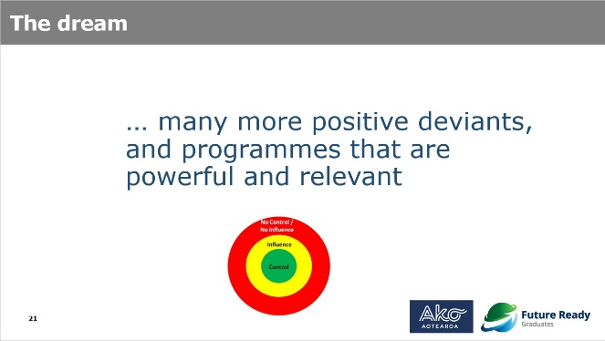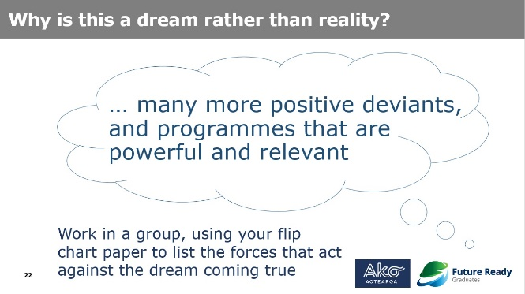

Activities and timing
(5 min) In groups, participants use flip chart paper to list the forces that act against their dreams coming true.
(2-3 min) Have each group provide feedback about several of the most important forces acting against their dreams coming true.

Resources
- 1 piece of flip chart paper
- Pen per participant

Part H: Eight crazy minutes (15 min) (3–hour workshops only)

Objectives
This part allows participants to remedy some of the challenges noted in Part G by coming up with as many ideas as possible in 8 minutes.
Get participants to search for ‘crazy ideas that worked’ on their phones. Let them have a few minutes to explore.
Explain that the exercise they are about to do is derived from a design thinking creativity exercise. They have 8 minutes to think of 8 ideas to make things better.
Use the following slides.
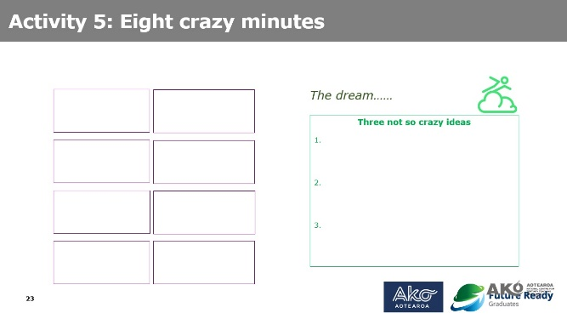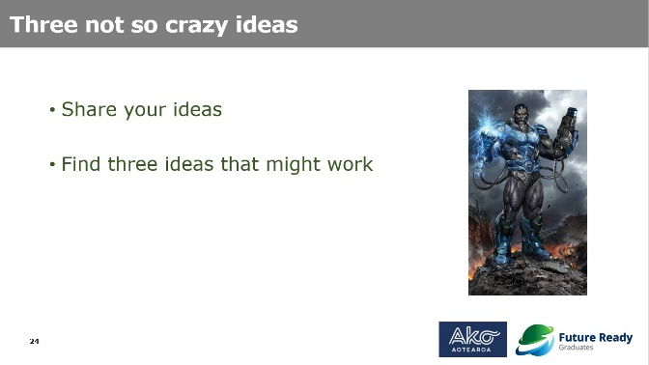

Activities and timing
(8 min) Each participant spends 8 minutes coming up with as many ideas as they can about how to improve the conditions to facilitate the changes noted in Activity 4.
(7 min) Have participants share ideas see if the class can find three decent ideas. Facilitators gather in some not so crazy ideas and congratulate participants.

Resources
- Copy of slides the Eight crazy minutes worksheet
- Pen per participant

Part I: Reflection and evaluation (20 min)

Objectives
This part reviews the workshop and invites participants to provide workshop evaluations.
Use the following slides.
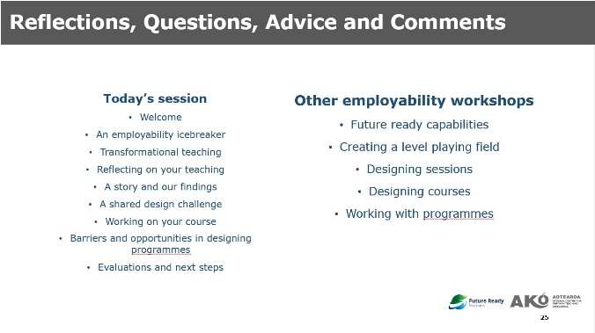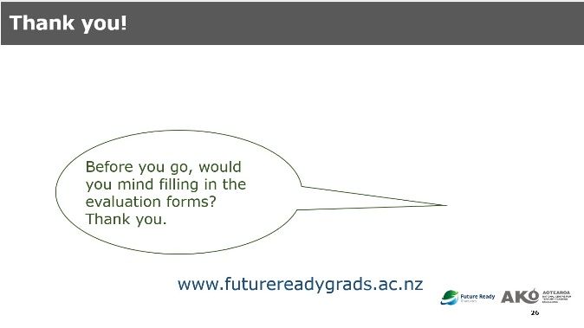

Activities and timing
(5 min) Review the workshop activities.
(10 min) Ask participants to share something they learnt or thought in the workshop.
(5 min) Give participants a copy of the slides and ask them to complete the evaluation forms. If you want to follow up with participants then take photos of their plans.

Resources
- Presentation slides for facilitator
- Evaluation forms per participant
- Copy of slides per participant
- iPad or smartphone
- Pen per participant

Attachment: Inventory checklist

Items | Quantity
Facilitator materials
Facilitator presentation slides | per facilitator
Attendance sheet | one for the facilitator
Facilitator guide | per facilitator
Invitation letter | per attendee
Facilitator bio | per group
Handout materials
Activity 1: institutional employability document | per group
Activity 1: which employability | per attendee
Activity 2: reflect on your course | per attendee
Activity 3: course scenarios | per group
Activity 3: ideas to fix the course | per group
Activity 4: embed employability into your course | per attendee
Activity 4: planning sheet | per attendee
Activity 5: Eight crazy minutes | per attendee
Evaluation form | per attendee
Attendee copy of slides | per attendee
Facilitation tools
Activity 1: a depressed graduate model | per group
Activity 1: employability gift box for ice breaker 1 | per group
Activity 1: employability tag & rope for ice breaker 1 | per attendee
Activity 3: stand for the shared design scenario | per group
Teaching aids & stationery
Timer to time each activity | one
iPad or smartphone to record/photo | one
White board marker | several for facilitators
Pen | per attendee
Sticky notes | in case
Permanent Marker | several per group (write name tag)
Blue tack | one bag
Tape | in case
Paper clips | in case
Scissors | in case
Batteries | in case
Name tag (for self-intro) | per attendee
Flipchart | in case
Food and drink
Bowl & plate | 2 per group
Paper cup | some
Snacks, sweets & chocolates | some
Tea and coffee | some

If research data is being collected, signed consent forms and participants’ activity sheets will need to be captured during the workshop. There are additional columns in the Attendance template for the facilitator to record the information.

